roid

217, Sheikh Rashid Building

P.O Box 56272, Dubai

United Arab Emirates

Tel: +971 4 2973236 / 04 2974007

Email: uae@verbat.com

PROJECT   
PROPOSAL

**SAADA Connect V 2.0**

|  |  |
| --- | --- |
| **Prepared for:**  **CarreFour** | **Submission Date:**  04 April 2018  **Proposal ID:** AD/BP/06042018/1343/1 |

___________________________________________________________________________________________________________________________________________  
Conﬁdentiality Notice: This Proposal is conﬁdential and contains proprietary information and intellectual property of Verbanet Technologies LLC. Neither this proposal nor any of the information contained herein may be reproduced or disclosed under any circumstances without the express written permission of Verbanet.

© 2017 by Verbanet Technologies LLC. All rights reserved. Confidential.

___________________________________________________________________________________________________________________________________________

Project Contacts

|  |  |
| --- | --- |
| Client Information | |
| Project Name | SAADA Connect |
| Client Name | CARREFOUR |
| Client Address | -------------------------- |
| Contact Person |  |
| Contact Person Email |  |
| Contact Person Phone Number |  |
| Verbat Information | |
| Contact Person | Joyce Daniel |
| Contact Person Phone Number | +971 42973236 |
| Contact Person E-Mail | [joyce.daniel@verbat.com](mailto:joyce.daniel@verbat.com) |
| Address | PO Box 56272, Dubai, United Arab Emirates |
| Physical Address | 217, Sheikh Rasheed Building, Hor Al Anz East |
| Project Information | |
| Proposed Technology/Methodology | MSSQL, C#, ASP.NET, IIS, MVC, Objective C, Java |
| Anticipate Start Date | NA |
| Proposal Valid For | 30 Calendar days from the submission of the proposal |

**Table of Content**

1 Scope of Work 6

1.1 Solution Objective 6

1.1.1 Phase1 Deliverables: 6

1.1.2 Phase 2 deliverables: 8

1.2 Advantages of Proposed Solution 9

1.3 Why Verbat 10

1.4 Key Differentiators 11

1.5 Technology & Services 12

2 Functional Specification 13

2.1 Mobile application (Android + IOS) 13

2.2 Web Application 13

3 Application Schematics 14

3.1 Feature Overview 14

3.2 Features in detail 15

3.3 MVVM Design Pattern 16

3.4 Application workflow 17

3.5 Use Case Diagram 18

4 Strategy for Mobile projects 19

4.1 Verbat’s Mobile Design Methodology 19

4.1.1 Roles 20

4.1.2 Storyboarding 20

4.1.3 Use-case diagram / behavioral diagram 20

4.1.4 User stories / behavioral specification 20

4.1.5 User-flow 21

4.1.6 Mind map 21

4.1.7 Wireframes 21

4.1.8 Prototypes 21

5 Nonfunctional Requirement (Others) 21

6 Assumptions 22

7 Out of Scope 22

8 Technology Solution 24

8.1 Proposed System Environment 24

8.2 Technical Configurations 25

8.2.1 Technical Specifications for Android 25

8.2.2 Technical Specification for IOS 25

8.2.3 Recommended (minimum) Web Hosting Package 25

8.2.4 Browser Compatibility 26

8.2.5 Hardware Interface 26

9 Commercials 27

9.1 Web Application 27

9.2 Payment Terms 27

9.3 Mode of Payment 27

10 Delivery Management 28

10.1 Project Management 28

10.2 Roles and Responsibilities 28

10.3 Delivery Activity Summary 29

10.4 Project Implementation Plan 29

10.5 Deliverables 29

10.6 Estimated Delivery Time 30

10.7 Deliverables 30

10.8 Release Planning 30

10.9 Risk and Contingency Planning 30

11 Change Management 31

12 Miscellaneous 33

12.1 Acceptance Criteria 33

12.2 General Terms and Conditions 33

12.3 Assumptions and Dependencies 34

12.4 Source Code & Intellectual Property Rights 34

12.5 Maintenance & Support 35

12.6 Service Level Agreement 36

13 Our Clients 37

# Scope of Work

SAADA CONNECT mobile App is an internal mobile application created for Carrefour UAE employees in both iOS and Android platforms. The main objective of the App is to communicate and engage with all of the employees internally.

The requirements is to enhance the current app, while keeping in mind that

* The app has bugs which needs to be removed
* The design is unfriendly, and the functionality is limited

The objective is to either build a new application from scratch or enhance the existing application.

This project will focus on enhancing the current App in terms of technical architecture, coding, security, design, and functionality. The project will be delivered in two phases to ensure a smooth process and an effective delivery to create a better employee experience for all of the approximately 11,000 users.

**Stand-Alone Fixed Bid**

Verbat will be following a stand–alone fixed bid solution delivery model wherein the required solution would be devised and a suitable pricing would be offered.

## Solution Objective

The project shall be delivered in 2 phases and the phase wise deliverables are described below

### Phase1 Deliverables:

* Code refactoring with appropriate architecture patters, security and encryption
* Design enhancement of the user interface
* SSO for users
* Enhance the happiness measurement by collecting additional feedback that pertains to the measurement (comments & ratings). This shall form the basis for additional multi-dimensional reports that detail the happiness level of the org
* Combine the News & Videos menus into one menu called “News “which needs the following enhancements:
  + Show the news feeds with the ability to scroll down to see older articles/news.
  + Ability to filter the news by dates.
  + News search option.
  + All the articles and news should be clickable and lead to an internal page of that specific article.
  + Remove the current format restrictions for uploading the images & videos for each Newsfeed.
  + Have the option to add multiple images/ videos in the same article or post.
  + Add Interactive images & videos with an option to the users to (zoom in/out, stretch, landscape/portrait mode…etc).
* Add new features: vacancies, benefits (to be .pdf compatible).
* Training feature to be added (in-app game is currently being designed by a third-party).
* Integrate the user’s profiles in the app, whenever the user logged in he will have his own profile with his photo, name, department, designation, BU. (PERSIS).
* Employees’ profiles search and review.
* Private chat on inbox with inbox search, and ability to disable receiving messages when needed.
* Enable the use of hyperlinks.
* Google Analytics (user data & content data).
* Dashboard for management to be able to view and generate reports for the user data & happiness meter (needs to be viewable on mobile phone).
* Link Apps from the App Store (NextCare, Carrefour, and MyHub).
* Add our Ethics Hotline contact details.
* In App messages (one-way communication).
* Have a survey tab along with a management report that will show the completion process, the result and segregation per BUs and with an ability to extract it on excel format, and considering the below:
  + When adding survey all users should be notified.
  + The ability to select more than one answer.
  + The ability to add text in some fields of the survey.
* Notifications feature in which, we need to consider the following:
  + We need all users to be notified on each update (news, survey ...etc.).
  + When clicking the notification it will take the user to the linked/related page. Even if the user clicked on old/viewed notifications, it should still take them to that page.
  + Notifications should not be removed after clicking on them but the color of the clicked/viewed notification should be different.
* To add a new tab for innovation with considering the below:
  + Ability for the users to post an innovation idea publicly. Posting an idea requires title, description and optional to post photo or video with limited size. Also the user can select using a check box if he wants to post anonymously for the public but still the admin can see user’s name. (other posting requirements to be confirmed later)
  + Other users can comment, like, dislike, and mention other user’s profiles on any posted idea.
  + General search by keyword.
  + Option of special campaigns in addition to the main campaign. Admin can define the campaign’s running time (for both, General and Special campaigns) so it will close automatically on the ending date. A message should appear when clicking on the closed/finished campaign to indicate that it is closed.
  + When selecting on a special campaign, users will be allowed to post inside that campaign’s page.
  + Giving the user the option to select between General or Special campaigns. List of the open special campaigns should appear when clicking on the “Special Campaigns” tab.
  + All innovations extraction reports to be separated from other reports.

### Phase 2 deliverables:

* More design enhancement if required.
* Pre scheduled posts.
* 360 video player.
* Integrate more systems with app (training agenda, LMS, etc.).

Verbat’s Solution architects have conducted a thorough research on the requirements and have come to the conclusion that our proposed solution, which is detailed further in this document, will meet the requirements put forth by the client. And the proposed solution will be delivered in a phased approach as per Verbat’s stand-alone fixed bid solution model.

**Strong and Scalable platform:** The platform proposed will be strong and scalable enough to accommodate future enhancements.

**Accelerated solution:** The framework would act as a solution accelerator. It would provide the basic building blocks which could be reused in future for building new components and features.

**High performance:** The light weight framework used consumes fewer system resources thereby making the application perform faster.

**Security:** The application will be developed considering various aspects of security.

## Advantages of Proposed Solution

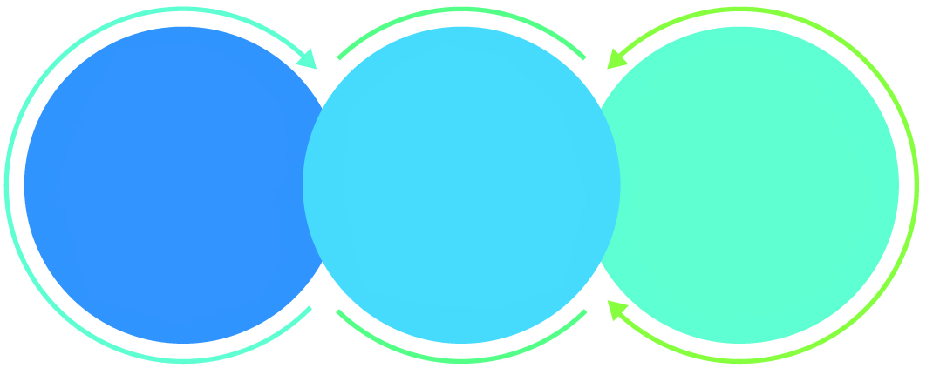

01

Agile development offering reliable, secure solution

02

Smooth transition and quicker completion of processes

03

User friendly interfaces enabling easy navigation between screens

## Why Verbat

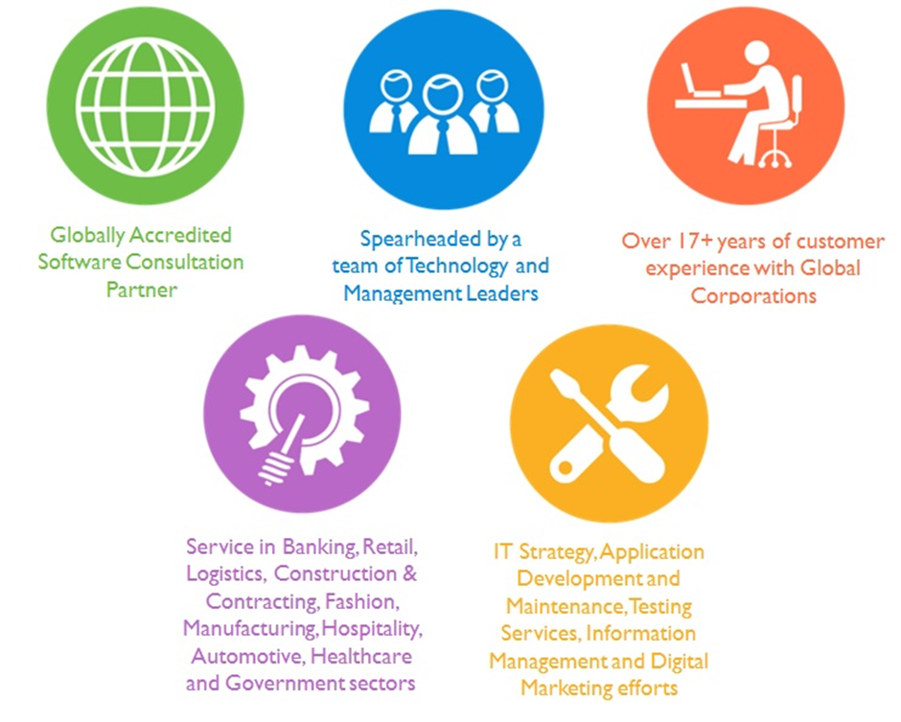

## Key Differentiators

Delivered digital transformation expertise to global customers for over a decade by following industry best practices to maximize ROI for client

Keen technology intelligence combined with aggressive market research to deliver solutions that achieve results with measurable value

Enable access to global consulting expertise with strong local market and business knowledge

Commercial Model that is customizable for your business needs

Services that are designed to optimize applications for improved performance and overall efficiency

1,000,000 plus man-hours of expertise in technology frameworks spanning Microsoft, Open Source, mobility platforms and other proprietary IT technology

Partners top technology vendors to bring in the latest and best services in integration, collaboration, and development

Commercial Model that is customizable for your business needs

Proven Methodologies & Processes

Investment in R & D

Strong Local Presence

Flexible commercial Models

Technology Associations

Software Development Experience

Offshore Development Centre

Quality Assurance & Testing

## Technology & Services

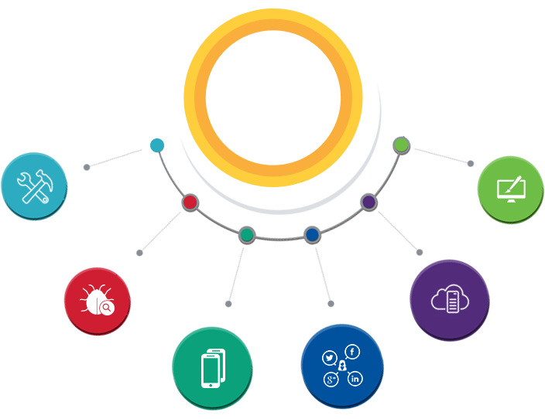

Technology  
&  
Services

Cloud/Traditional Hosting

User Interface & Design

Digital Marketing

Mobility Solutions

Testing Services

Application  
Development

# Functional Specification

## Mobile application (Android + IOS)

Mobile App Features that shall be developed

|  |
| --- |
| **Development** |
| **PHASE 1** |
| Basic Setup |
| Splash Screen |
| Login- Single Sign On Mechanism, auto password change/reset |
| Happiness page - comment , generate report |
| News listing(News + videos) -news feed, filter news by dates, search news |
| News details page - add multiple images, interactive images |
| Vacancies listing |
| Vacancies details page |
| Benefits listing |
| benefits details page |
| Training listing |
| Training details page |
| Profile page |
| Profile search and review |
| Private chat |
| Google analytics |
| Add Ethics hotline contact details |
| Push notifications |
| Survey listing and view |
| Notification list page |
| Notification detail page |
| Innovation - post innovation, anonymous posting, comment, like, dislike, search by keyword |
| Campaign listing page - General/special, pop up when closed |
| Special Campaign - list , post |
| Logout |
| **PHASE 2** |
| Prescheduled posts |
| 360 video player |
| **API Integration** |
| API Integration |

## Web Application

|  |
| --- |
| **Web Development** |
| Basic Setup |
| ***Phase 1*** |
| Report to measure the overall happiness |
| News |
| Option to add multiple images/ videos |
| Vacancies |
| Add, Edit, List & Delete |
| Benefits |
| Add, Edit, List & Delete |
| Training feature to be added |
| Dashboard |
| Ethics Hotline contact details |
| Survey |
| Add, Edit, List, Delete, |
| Report |
| Excel Export |
| Push Notification |
| Innovation |
| View innovation |
| Reports |
| Campaigns |
| Add, Edit, List, Delete, |
| ***Phase 2*** |
| Pre scheduled posts |
| Integrate more systems with app |

## Web API

|  |
| --- |
| **Web Development** |
| Basic Setup |
| Users login |
| Happiness measurements |
| News |
| News feeds with the ability to scroll down to see older |
| Filter the news by dates |
| Search option |
| User’s profiles |
| View |
| Update |
| Employees’ profiles search and review |
| Ethics Hotline contact details |
| Innovation |
| Post an innovation |
| Users can comment, like, dislike |
| Search by keyword |
| Campaigns |
| General or Special campaigns |
| Post Campaign |

# Application Schematics

## Feature Overview

## Features in detail

## MVVM Design Pattern

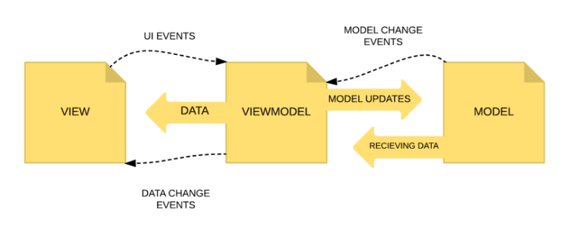

With the introduction of the data-binding library in Android (Marshmallow version – 2015), Verbat has been deploying applications using the MVVM pattern for Android. MVVM can be implemented in both IOS & Android. MVVM is an excellent pattern that reduces the amount of code on Views and makes code cleaner, maintainable, reusable and testable, no matter what platform is being employed during development. Also, MVVM makes life easier by making allowance for cross-platform app development.

## Application workflow

## Use Case Diagram

# Strategy for Mobile projects

While mobile development is rooted in methodologies inherited from web and software development – Waterfall or Agile; Scrum and Kanban – there is no industry-standard methodology for the design stage of mobile projects.

When you consider how important design and user experience (UX) is to the success of mobile projects – neither traditional techniques like Waterfall or modern techniques like Agile fill the gaps.

This is because the development process for mobile projects are different. Consider the typical process for mobile application development

* Visualization of the project through storyboarding
* Testing the storyboard on the target audience, then refining it.
* Getting agreement from stakeholders, then refining it.
* Defining structure, look and feel and user interface – using wireframes.
* Test again, refining and getting agreement.
* Creation of a prototype – usually digital.

The traditional methodology for software development, usually referred to as Waterfall, is a linear process of defined stages: research -> design -> development -> test -> deploy (or similar).

While this makes design just a stage in a development process, the advantage is that actual development can’t start until design is completed and signed off.

In web and particularly mobile development, there is a need for speed, a requirement to work on different parts of the project concurrently, for regular scheduled testing and to continually enhance and upgrade.

Agile development methodologies such as Scrum or Kanban, allow for research, design, development, testing and deployment – all different aspects of the project – be done at the same time.

While agility brings many advantages, there is a danger for the design process to become squeezed, rushed, overlooked or, if outsourced, cause lack of continuity and delays. This makes it all the more important to put in place a design methodology.

## Verbat’s Mobile Design Methodology

Verbat divides the design process into user experience techniques.

### Roles

The first of UX techniques to design an app is about identifying roles. Roles do not necessarily belong to people only. They can be the end user of the product, a mobile device, a server the app will communicate with, an organization the app is going to serve for and all other personas engaged in the interaction with the final product when it is being used. Verbat identifies the roles in order to understand the ecosystem where the product will be in use. Understanding the user experience landscape helps define the functions the app is going to perform, as well as the scope of work each role has to complete.

### Storyboarding

The common mistake is to trivialize the situation and assume that it doesn’t need to be spelled out. However, when you take a simple scenario of user interaction with your product and break it down into tiny pieces, you will notice a lot of issues you haven’t paid attention to. Storyboarding is exactly what you need to take into account all the nuances, determine design solutions and put them to the fore.

Storyboarding helps us to think. It helps us understand existing scenarios, as well as test the hypotheses for potential scenarios. A designer’s main skill is not Photoshop, but the ability to formulate and describe a situation or a scenario. You divide the user of the product into a bunch of different characters and try out various stories that can happen to a particular character.

### Use-case diagram / behavioral diagram

Behavioral diagram describes behavior of external users (actors) visually. It identifies the exact actions each actor can take. For example, in a library, there are two actors. One is a librarian, the other one is a library customer. The library customer can search for or borrow a book, whereas the librarian can search for a book, add a book and remove a book.

### User stories / behavioral specification

Each user story is an actual written description of each use case. All user stories start with “As a user I can…” and then follows a detailed description of what a user can do with the app.

When all the user stories are thoroughly outlined, sprint planning can be started. For this, we set priority for each use case and estimate the time in hours it will take to implement the function described in the user story. The highest priority items go to the production first. A sprint usually lasts one-two weeks. Its scope is planned according to the number of hours we need to implement a certain function.

### User-flow

When we have finished working on user stories, we get a clearer idea of the user interaction with the mobile application. This helps us create a diagram of the user behavior or a user flow.

### Mind map

The user-flow helps to identify a set of functions for each page and how the screens intersect. Mind map represents the architecture of the product. It illustrates the structure of the app and relations between elements.

### Wireframes

Wireframes are the skeletons of the final design. The point of wireframes is to assign functionality to each screen and show the dependency between the screens. It’s the ultimate draft before coloring. Only when each wireframe is discussed with the team and approved by the client do we start working on colorful buttons, beautiful animations and original custom elements.

### Prototypes

Wire-framing is followed by the mockups creation. We make prototypes of the mockups and send them to the client one by one. This way the client gets a working prototype that looks exactly like the future product.

# Nonfunctional Requirement (Others)

|  |  |
| --- | --- |
| **Requirement** | **Details** |
| User Experience and  UI Design | * The application will be developed only in English and Arabic * The layout and graphical components will be created considering the usability factors |
| Performance | * Application will allow users to have smooth and quick access to the information or services they require. |
| Security | * The system will be protected against attempts of security breaching that may arise. * Web security standards will be followed. |

# Assumptions

The project solution and technology is created from the initial understanding of the requirement shared with Verbat through mails and meetings. The proposed solution is based on the following assumptions:

* Client to provide Verbat with the branding guidelines.
* The proposed application will be bilingual (English & Arabic)
* Client will purchase the necessary templates needed for development
* Client shall provide licensed images and logos in specified size & format
* Requirements should be well defined, agreed and signed-off by the client
* Internet connectivity is required for the functioning of the web application.
* Testing will be done in latest versions of Google Chrome, Mozilla, Safari, & Edge web browsers only
* Development Contingent upon timely feedback from client
* Application shall support SDK version 19 (KitKat) and above
* Application designed for mobiles in portrait mode

|  |
| --- |
| * Cloud hosting of images shall be provided by client * Integration with other systems shall be estimated based on the details of the systems to be integrated. Necessary details like integration document, test access and APIs shall be provided by the client |
| * Details of the training feature shall be provided by the client |
| * Vimeo account shall be used for Video uploads |
| * The performance of the upload shall depend on the performance of the third party services like Vimeo, internet connectivity and speed * Additional effort will be required for |

# Out of Scope

Following are considered to be out of scope while creating this proposal.

* Purchase of images, fonts
* Adding new features to the application other than mentioned in the functional specification.
* Any language other than English & Arabic
* Manual data entry
* Hardware Integrations / procurement and purchase
* Database migration
* Content writing
* Content or image procurement or uploading or editing.
* Hosting Infrastructure and Maintenance
* Annual Maintenance of the application (Bug fixing, debugging) - For AMC details, please refer section titled “Maintenance and Support”
* Physical deployment at client’s site
* Backup solution and Disaster recovery
* Time and attendance module is not included within this proposal
* Application deployment

# Technology Solution

## Proposed System Environment

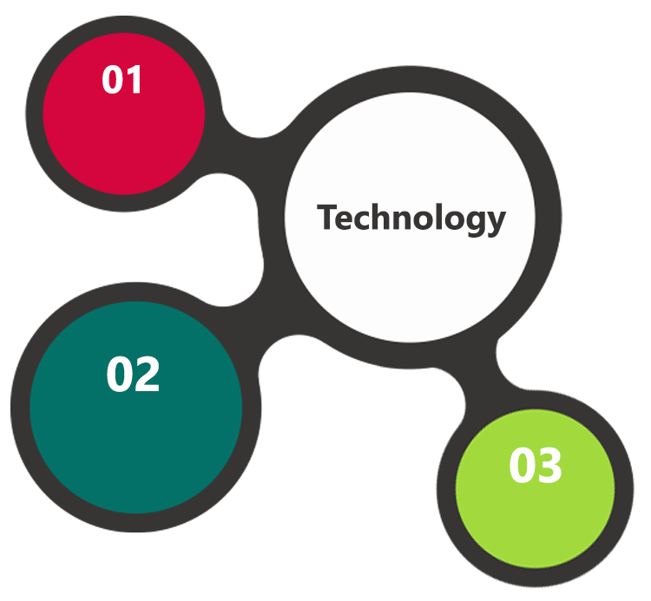

C#, ASP.net /

Objective C, Android SDK, IOS SDK

Mssql, IIS, MVC

HTML / CSS3/ Jquery

**MS SQL2012  
Windows 8/10  
Web Services**

## Technical Configurations

### Technical Specifications for Android

* Editor - Android Studio(Android) 5
* Min SDK version - TBD (Recommendation - 19)
* Device Support - TBD (Samsung, HTC, LG, Nexus)
* Orientation support - Portrait (Video playing screen will
* support the landscape mode also )
* Programming Language - Java, support Kotlin.
* Reactive programing - RxJava
* UI/UX Design - Android Material Design (to be
* discussed)
* Localization - (English & Arabic)
* Networking - Retrofit 2, OKHttp
* Database - N/A
* Image loader - Glide or Picasso

### Technical Specification for IOS

* Editor - Xcode
* Min OS version - iOS 10
* Device Support - iPhone 5s and above
* Orientation support - Portrait (Video playing screen will support the landscape mode also)
* Programming Language - Swift.
* Reactive programing - N/A
* UI/UX Design - Storyboards
* Localization - (English & Arabic)
* Networking - Alamofire
* Database - N/A
* Image loader - Alamofire, SDWebimage

### Technical specification for web development

* Editor – Visual Studio
* Languages: C#, ASP.NET
* Framework: ASP.net MVC
* Database Server: MSSQL
* Scripting: JQuery

### Recommended (minimum) Web Hosting Package

* OctaCore CPU
* RAM: 32 GB
* Disk Space: 1 TB
* Monthly Bandwidth: 20 TB
* Web site Server Software – Apache

### Browser Compatibility

* Chrome version: 56
* Firefox version: 51
* Edge version: 39
* Safari version 10.1

### Hardware Interface

**Desktop**

The application is reliant on hardware interfaces to provide a seamless automated user experience.

* Computer with Windows 8 or 10 OS
* Compatible Browsers as specified in section 7.2.3

# Commercials

## Web Application

|  |  |  |
| --- | --- | --- |
| **No** | **Description** | **Amount (USD)** |
| 01. |  | 00,000.00 |
| 02. |  | 00,000.00 |
|  |  |  |

*Note:*

* *The above cost does not include Application hosting, integration, Project Management or deployment*
* *For change management cost, please refer to section 10 titled Change Management*

## Payment Terms

*Note: Payment should be made within 7 days from the date of the invoice*

## Mode of Payment

By Cheque / DD to Verbanet Technologies LLC

OR

Wire transfer to our bank account

Bank Name : Emirates NBD

Account Name : Verbanet Technologies LLC

Account Number : 1011492858201

IBAN Number : AE61 0260 0010 1149 2858 201

Swift Code : EBILAEAD

Bank Address : Mamzar Branch, Dubai

*Note: Bank charges incurred during wire transfer to be borne by the client. Any local taxes applicable to be borne by the client*

# Delivery Management

## Project Management

The Verbat development center strictly follows industry standards on quality. The project management is process governed by the Verbat Quality Management system and is put to verification through internal audit programs that happen from time to time.

Verbat will dedicate a project manager for the proposed implementation. Verbat proposes Client to identify one project manager who will be driving activities to be undertaken by Client to be the single point of contact for Verbat.

## Roles and Responsibilities

Verbat will assign a dedicated Project Manager/Project Lead to lead the project, who will be the first point contact for Client. He/she will be responsible for planning and managing the various activities within the project. He/she will work closely with Client Project Manager, to give periodic status updates and ensure high level of visibility and comfort on the progress of the project.

The Project Manager/Project Lead will lead the co-ordination between Verbat and Client, thus enabling smooth transitioning of Client requirements to the Verbat’s offshore delivery team, and provide visibility as well as comfort on the progress of the services to Client.

He/she will have periodic meetings with Verbat’s Senior Management, thus ensuring Verbat’s Management commitment and focus on Client initiatives.

## Delivery Activity Summary

|  |  |
| --- | --- |
| Activities | Description |
| Detailed requirement Analysis | Verbat team to conduct detailed study of requirement for the phase. If clarification is required, team will reach out to Client for more information and/or time for discussions. |
| DB Design | DB design for central and test DB. |
| Software Requirement Specification document (SRS) | Once the requirement analysis is completed, Verbat team will submit the SRS document for approval |
| UI/UX Design, Prototyping | Based on the SRS, Verbat UX/UI team will work on the UI/UX of the screens and submit a prototype for approval |
| Functional Specification Document (FS) | Once the Prototype. UI/UX is approved, Verbat shall submit an FS document for approval. |
| Development | Actual system development starts based on the FS. This involves detailed design and software development of Web Application. |
| Testing | Test Planning, test plan creations, internal, integration testing and user acceptance testing. |
| Deployment | Deploying the latest built in the Verbat Test Server. |

## Project Implementation Plan

Verbat will be providing the solution in a stand-alone fixed bid approach which ensures minimum viable solution for quick wins with core focus on the long-term business objective and outcome. Once the implementation is over, Verbat will initiate the application maintenance process (once the maintenance contract is signed) which continues to extend after the implementation.

## Deliverables

* Project Plan
* Software Requirements
* Prototype of the application
* Test Plan Document
* Source Code
* Fully Developed & Tested Application

## Estimated Delivery Time

Each sprint is **15 working days**

|  |  |  |  |  |
| --- | --- | --- | --- | --- |
| Sprint 1 | | | | |
| Basic Setup | Web |  | Web API |  |
| Splash Screen |  |  |
| Login- Single Sign On Mechanism, auto password change/reset |  | Login |
| Happiness page - comment | Happiness Report | Happiness post |
| Dashboard | Dashboard | Dashboard |
| Logout |  | Logout |
| Unit test cases | Unit test | Unit test |
| Sprint 2 | | | | |
| News listing(News + videos) -news feed, filter news by dates, search news | Web | Add, edit, list & delete News | Web API | News list, filter by date, search news |
| News details page - add multiple images, interactive images |  | News details |
| Vacancies listing | Add, edit, list & delete Vacancies | Vacancies listing |
| Vacancies details page |  | Vacancies details |
| Benefits listing | Add, edit, list & delete Benefits | Benefits listing |
| benefits details page |  | Benefits details |
| Unit test cases | Unit test | Unit test |
| Sprint 3 | | | | |
| Training listing | Web | Add, edit, list & delete Training | Web | Training List |
| Training details page |  | Training Details |
| Profile page |  | Profile Page |
| Profile search and review |  | Profile search and view |
| Survey listing and view | Add, edit, list & delete Survey | Survey listing and view |
| Notification list page |  | Notification list |
| Notification detail page |  | Notification detail |
| Unit test cases | Unit test | Unit test |
| Sprint 4 | | | | |
| Innovation - post innovation, anonymous posting, comment, like, dislike, search by keyword |  | View and report |  | Innovation listing and post comment like, dislike search |
| Campaign listing page - General/special, pop up when closed | Add, Edit, List, Delete campaign | Campaign list |
| Special Campaign - list , post |  | Special Campaign list |
| Prescheduled posts | Notification to user |  |
| Unit test cases | Unit test | Unit test |
| Sprint 5 | | | | |
| 360 video player | Web |  | Web API |  |
| Private chat |  |  |
| Add Ethics hotline contact details | Update Ethics hotline contact details | Ethics hotline contact details |
| Google analytics |  |  |
| Unit test cases | Unit test | Unit test |

## Deliverables

The list below is a brief overview of the items that will be delivered mainly for referral purposes. The actual items delivered will be vary based on the decisions made at the time.

1. Working IOS Mobile application
2. Working Android IOS application
3. Working Web application

## Release Planning

* Client will be informed about the release date and time through email.
* Client performs the UAT

## Risk and Contingency Planning

Verbat has identified various risk factors associated with this assignment and understands the impact of these risk factors on the project schedules. The objective of this section is to highlight for both Verbat and client, the risk factors, to analyze the impact of the risks on project execution, and to propose strategies to control and reduce the impact of the risk factor.

These various risks, which could arise during the project, are tabulated below along with mitigation implementation.

| Type of risk | Impact | Risk Mitigation | Risk Handling |
| --- | --- | --- | --- |
| Scope Creep | H | Functions and features will be detailed in system requirement documents and will go through client approval. Once this document is approved, any change to requirement will go through change management review for possible impact assessment. | Proper change management procedure will be implemented. |
| Delay in customer feedback | H | The plan is prepared with enough lead-time for customer reviews and approvals.  The customer is indicated with the dates when the document is expected after review and approval. | The request for feedback will be escalated if not attended at the right time so that the schedules are not affected. Deemed acceptance criterion is set up front and will be followed. |
| Non-availability of necessary software’s, frameworks, database instances and infrastructure at client’s hosting environment(If hosting support is provided by Verbat) | M | Client will be informed in advance on these requirements. | Possible impact to schedule. |
| Manpower attrition | L | All efforts would be made to ensure process dependence rather than being person dependent. As a risk mitigation plan Verbat will train backups. | A new person will be identified as early as possible, provided the required project-specific training and mentored by the senior members of the team to minimise impact of attrition on the project. |

*H-High, M-Medium, L-Low, NA-Not Applicable*

# Change Management

Any addition which comes out of the project scope, upon and after the launch of the tool will be considered as change management. Verbat recommends the following change management procedure for the same.

* Any change which comes out of the project scope, which was discussed, documented, and mutually approved by both the parties in the requirement stage, will be carried out only through raising a change request.
* Change request will be studied and an impact analysis on the existing work flow will be performed.
* On finalizing the impact, effort estimation for the change will be calculated and raised as additional requirement.
* Verbat will initiate the change request only after getting a formal approval from the client for the additional changes raised.
* Any change from the scope will be charged at **USD ----- per man day effort** and approval from the clients will be availed before commencing on any change management.

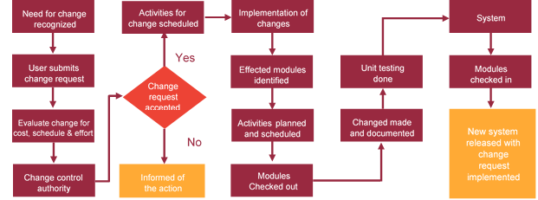

# Miscellaneous

## Acceptance Criteria

* UAT sign off should happen within 14 Days from the release of the application/ Phase and the acceptance confirmation needs to be mailed to Verbat failing which Verbat will consider the project as approved by the client.
* Any comments or reason for rejection need to be documented and the same needs to be sent as an email from the official mail id of client to Verbat.

## General Terms and Conditions

* All the projects activities will be carried out from our off-shore development center in India
* The scope of the project is to develop the Application as detailed in the scope of the project and mentioned in this proposal. Any changes or additions will have to go through change management.
* This proposal and all technical/ functional specifications have been derived or concluded from the data shared via email / information's transferred during the initial requirement analysis meetings and conversations. Verbat reserves the right to amend the terms of this proposal, should the SOW terms, functional features and functionalities change during the course of the project
* Application will be best viewed only in the environment mentioned in this document
* All the documentation will be provided in English.
* Third party components may be used to develop this application.
* All Source Code and other project artefacts would adhere to the Verbat document templates and internal coding standards
* Client shall provide the respective enterprise apple store and Google play store accounts for development and production
* Acceptance criteria shall be based on the clauses which were mutually discussed between Verbat and client at the Requirement Analysis phase and the same will be documented and approved by both parties through official emails
* In case Client requires any extension of the proposed acceptance schedule, the associated effort and cost of such extension can be mutually reviewed.
* For any circumstances if project needs to be put on Hold / Stop it requires minimum request notice period of 2 weeks along with duration for which request will be addressed by management and final decision on the request will be based on that
* If deployment is done in client’s server, Verbat cannot be held responsible for any performance issues arising due to hardware malfunctions.
* Source code will only be delivered or uploaded on the Production Server once the due payments are made.

## Assumptions and Dependencies

* Detailed system study is required before the start of the project.
* During the requirement gathering phase, authorized personnel from the Client’s side is expected to be available for discussion and finalizing the HLD (High Level Design), before development commences.
* Type of reports and formats, if under the scope of the project, needs to be specified by Client before project sign off.
* Workflows if under the scope of the project, need to be specified/ confirmed by client before project signoff.
* All queries regarding the client requirement and any queries which may hinder the project advancement at any stage should be answered by the client within 24 hours from the time of initiation, failing which the time delay will get added to the actual effort which was estimated.
* Verbat assumes that all sign-offs from Client will be provided within agreed and specified timeframe.
* Client will provide all the necessary contents, both text and image, before starting the project in the format suggested by Verbat (if any).
* The client should provide the relevant information and data well in time for the execution of a related activity. Non- availability of this information or data may lead to an interruption of work which may result in a delay in delivery as well as additional costs to the client.

## Source Code & Intellectual Property Rights

* Upon completion of the Project and 100% completion of the payment, client will have access to the source code except for propriety codes, developer tools and third party application etc.
* The solution offered will be the intellectual property of the client and will be made available to the client on an “unlimited license” basis.
* Modifications by third party/person: No person or organization, other than Verbat or any person authorized by Verbat in writing, has any permission to modify/change the software Solution to be eligible to get continued support from Verbat as per the support terms defined under this document.
* Liabilities/Damages: Verbat accepts no liability or damages of any kind arising out of use or non-use of the software delivered. The responsibility of testing of software lies with Client.

## Maintenance & Support

* Maintenance contracts by default are supported as per the basic SLA terms.
* **AMC with Basic SLA is charged at 20 % of the total project value**. Additional Effort/change management request will be added towards Total Value of the Project to determine the AMC value.
* Maintenance support is limited to providing application support for ensuring the consistency of the look-and-feel, bug fixes and user issues i.e. maintenance and support of the existing features of the application.
* Support does not in any way cover providing technical or other support to the end users. The maintenance agreement does not include functionality changes or feature additions which are handled as change requests which will be charged AED 1200 per man day. AMC does not include server support, maintenance and application deployment.
* AMC charges will cover Off-Site Support and Debugging. Support includes E-mail, Telephone and Chat unless explicitly specified. In the event, the application is hosted with the client; necessary remote desktop connectivity should be provided for carrying out maintenance activity.
* Gap in AMC - In case if the client does not opt an AMC for a year and want to renew it after that period, 50% of the AMC amount for the year for which AMC is not taken will also be payable if the client wishes to renew the AMC contract.
* Note:
  + Please note that the AMC support shall start only after all the necessary sign-offs (AMC Document) to this effect have been given.
  + It is not mandatory that the client should opt for an AMC. The client will still be supported on an ad-hoc basis on an agreed man-day rate.
  + AMC Payment Terms: 100% to be paid as advance.

## Service Level Agreement

|  |  |  |  |  |
| --- | --- | --- | --- | --- |
| **Key** | **Max Response Time** | | **Max Resolution Time** | **Target** |
| Basic | 1  working day | 3 working days | | Request / incident / problem tickets |
| Advanced | 5 Business Hours | 12 Business Hours | | Request / incident / problem tickets |
| Priority | 3 Business Hours | 5 Business Hours | | Request / incident / problem tickets |

Note:-

* We provide Basic SLA as standard with AMC while Advanced and Priority SLAs attract additional charges.
* Time zone applicable as per India time zones (3:30 AM GMT to 12:30 PM GMT- Monday to Friday).

# Our Clients

**UAE University**

Education

Transportation

**Canada Cartage**

Construction

Services

Finance

We look forward to hearing from you soon and hope that you will give us the privilege to work with you in meeting your business goals. Thank you.

Thank You



©   
1999 - 2017. All Rights Reserved   
Verbanet Technologies LLC  
www.verbat.com